Why do Hindus worship the cow?
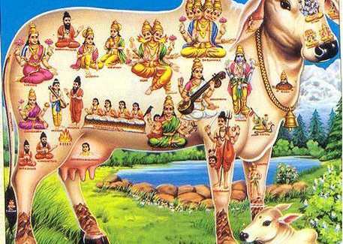

Hindus don’t worship cows. We respect, honour and adore the cow. By honouring this gentle animal, who gives more than she takes, we honour all creatures.
Hindus regard all living creatures as sacred – mammals, fishes, birds and more. We acknowledge this reverence for life in our special affection for the cow. At festivals we decorate and honour her, but we do not worship her in the sense that we worship the Deity.
To the Hindu, the cow symbolizes all other creatures. The cow is a symbol of the Earth, the nourisher, the ever-giving, undemanding provider. The cow represents life and the sustenance of life. The cow is so generous, taking nothing but water, grass and grain. It gives and gives and gives of its milk, as does the liberated soul give of his spiritual knowledge. The cow is so vital to life, the virtual sustainer of life, for many humans. The cow is a symbol of grace and abundance. Veneration of the cow instils in Hindus the virtues of gentleness, receptivity and connectedness with nature.
Elaboration: Who is the greatest giver on planet Earth today? Who do we see on every table in every country of the world –breakfast, lunch and dinner? It is the cow. McDonald’s cow-vending golden arches and their rivals have made fortunes on the humble cow. The generous cow gives milk and cream, yogurt and cheese, butter and ice cream, ghee and buttermilk. It gives entirely of itself through sirloin, ribs, rump, porterhouse and beef stew. Its bones are the base for soup broths and glues. It gives the world leather belts, leather seats, leather coats and shoes, beef jerky, cowboy hats – you name it. The only cow-question for Hindus is, “Why don’t more people respect and protect this remarkable creature?” Mahatma Gandhi once said, “One can measure the greatness of a nation and its moral progress by the way it treats its animals. Cow protection to me is not mere protection of the cow. It means protection of all that lives and is helpless and weak in the world. The cow means the entire subhuman world.”
In the Hindu tradition, the cow is honoured, garlanded and given special feedings at festivals all over India, most importantly the annual Gopashtama festival. Demonstrating how dearly Hindus love their cows, colourful cow jewellery and clothing is sold at fairs all over the Indian countryside. From a young age, Hindu children are taught to decorate the cow with garlands, paint and ornaments. Her nature is epitomized in Kamadhenu, the divine, wish-fulfilling cow. The cow and her sacred gifts –milk and ghee in particular –are essential elements in Hindu worship, penance and rites of passage. In India, more than 3,000 institutions called Gaushalas, maintained by charitable trusts, care for old and infirm cows. And while many Hindus are not vegetarians, most respect the still widely held code of abstaining from eating beef.
By her docile, tolerant nature, the cow exemplifies the cardinal virtue of Hinduism, noninjury, known as ahimsa. The cow also symbolizes dignity, strength, endurance, maternity and selfless service.
In the Vedas, cows represent wealth and joyous Earthly life. From the Rig Veda (4.28.1;6) we read. “The cows have come and have brought us good fortune. In our stalls, contented, may they stay! May they bring forth calves for us, many-coloured, giving milk for Indra each day. You make, O cows, the thin man sleek; to the unlovely you bring beauty. Rejoice our homestead with pleasant lowing. In our assemblies we laud your vigour.”

