Short
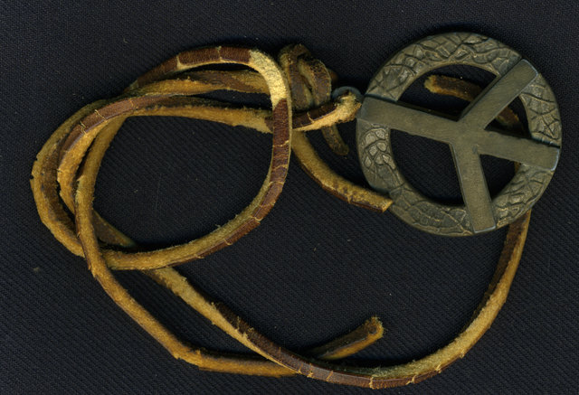
Zero…
It’s not often in life that having nothing is a desire, much less an outright obsession. But, in Vietnam it was the most sought after goal of every soldier, the beacon of light at the end of a harrowing journey. It was the hint of survival as the days of duty counted down, from too-many-to-think-about, to numbers that reminded one there was an “other” reality” back in “the world” beyond the jungles and rubber plantations. Numbers that dwindled until, in a day you had feared would never come, your number hits Zero and you hop aboard the “Freedom Bird” to wing your way toward family and friends, toward a place where you can breathe freely once again.
Most men in A Battery kept one or more short timer's calendars. The first 30 days I did not start one, but when I did start, I created 12 of them, so I could mark off a day as served every 2 hours. Most men used a matrix of cells that represented the days they needed to survive; somewhere around 365. A cell would be blacked out when a day was served and the remaining open cells were a graphic representation of the days ahead. The matrix looked like a Tic-tac-toe board on steroids.
“Being short” was not only the goal of every soldier, it was also the ultimate status. Even the Vietnamese understood the importance of a soldier being “short”, and treated short-timers differently. Fellow soldiers also gave short-timers a wider berth, accepting behaviors that would not be tolerated in others. I had five suits custom tailored by a Korean who had a small shack near the PX, even designed them myself. 45 days after my return to the states I gained so much weight they no longer fit. Vietnam was a sauna, so very few vets went home fat and I never saw a fat Vietnamese.
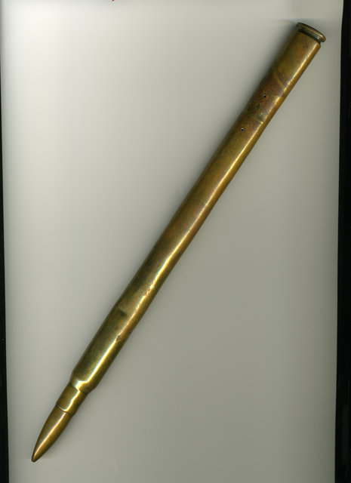
No longer restricted to C-Rations, I ate like a pig. My friend, Thelma Clark, sent me a restaurant review book for San Francisco: “The San Francisco Underground Gourmet: An Irreverent Guide to Dining in the Bay Area: Dinners from $2”, by R.B. Read. I studied it and picked out several restaurants I had to try after my discharge from the Army, upon my return to “the world”. I managed to eat at eight of the hundreds of restaurants reviewed in the book.
While there was no official definition of “short”, 30 days was a common first step – then 15 days, 10 days, and finally seven days. At the 30-day mark, soldiers began to withdraw from the “Nam Reality” and become much more cautious. They’d shy away from the more dangerous jobs, and stay closer to base. Some carried an object, called a short timers stick that displayed to all that this person was going home soon. They began to think first before they acted. This would serve them well back in the “the world”, instead of the act-first, think-later attitude required to survive in Vietnam.
I believed I would die in Vietnam but when I suddenly felt short, I began to think I might make it home in one piece.
When my number hit 30, I made the change in thinking. I was listening to Jose Feliciano on the radio, and I remember him signing “Come on, Baby, Light my Fire.” It was the last song I’d heard in the States on my journey to Vietnam. All of the sudden I felt that I could survive – that my numbers could dwindle from 30 to 15, then 10 and seven.
Zero was possible!

READING QUESTIONS:
- How did soldiers keep track of their time in Vietnam? Why do you think the author might not have started during his first month in Vietnam?

- What does the term “short” mean? How did soldiers who were short think and act differently?

- What do you think it means to be back in “the world?” How did the author prepare for this?

- What happened to the author once he returned to “the world?” What were two reasons why this happened?

- Based on this reading, what was the ultimate goal of the average American soldier in Vietnam?

