Napoleon DBQ
The following question is based on accompanying documents 1-12.
This question is designed to test your ability to work with historical documents. As you analyze each document, take into account its source and the point of view of the author. Write an essay on the following topic that integrates your analysis of the documents. You may refer to historical facts and developments not mentioned in the documents.
Question:
Analyze the validity of the argument of whether Napoleon Bonaparte was a tyrant or a hero.

Historical Background: In France, after the conclusion of the French Revolution, where the people in France revolted against their government, a new leader, Napoleon Bonaparte emerged. Napoleon’s aggressive foreign policies allowed him to conquer many other countries after he was recognized as a brilliant military leader. He would eventually become Emperor.

Document 1

A letter from Jean Victor Marie Moreau, French General, to Napoleon in May 1804.
You swore to establish a government, not depending upon the life of one individual, not tyrannical but firm, stable and liberal; bestowing freedom on Frenchmen, and worthy to obtain by gratitude from foreign nations, that confidence and esteem, which your predecessors and yourself have commanded by the dread of your bayonets. When I shortly afterwards went to lead armies -- disorganized and defeated -- your last words were: 'I know your love of your country; be victorious, and France shall force admiration, even from her rivals and foes, by the liberty she enjoys at home, and by the generosity of her external negotiations!' How have you respected these fulfilled these promises? How have you respected these oaths? In my degraded country, I see nothing but cringing slaves and proud tyrants; base placemen and infamous spies. Everywhere in Europe, from Sicily to Moscow, yourself are alike feared and detested.

Document 2

From Napoleon’s diary entry on December 30, 1802

My power proceeds from my reputation, and my reputation from the victories I have won. My power would fail if I were not to support it with more glory and more victories. Conquest has made me what I am; only conquest can maintain me. Friendship is only a word; I love nobody; no, not even my brothers. Perhaps Joseph a little; even then it's a matter of habit, it's because he is my elder. -Duroc? Ah, yes, I love him; but why? His character attracts me: he is cool, dry, severe; and Duroc never sheds tears. As for me, you don't suppose I care; I know perfectly well I have no real friends. As long as I remain what I am, I shall have as many as I need so far as the appearance goes...

Document 3

From the Napoleonic Code
Title I: Of the Enjoyment and Privation of Civil Rights
- The exercise of civil rights is independent of the quality of citizen, which is only acquired and preserved conformably to the constitutional law.
- Every Frenchman shall enjoy civil rights.

Document 3

From Napoleon’s Proclamation to Troops

Peoples of Italy, the French army comes to break your chains; the French people is the friend of all peoples. Come to them with confidence. Your property, your religion, and your customs will be respected. We are waging war as generous enemies, and we wish only to crush the tyrants who enslave you.

Document 4

“Napoleon at St. Bernard” painting by Jacques-Louis David

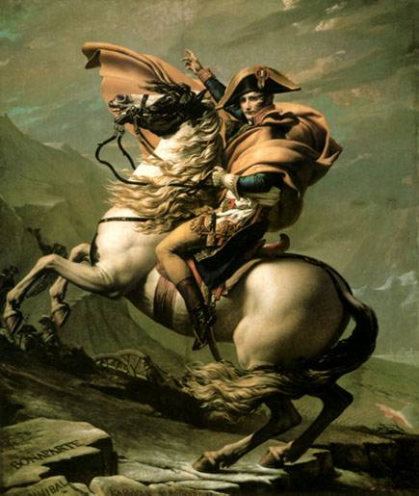

Document 5
A speech by from April 20, 1814, by Napoleon Bonaparte, after his failed invasion of Russia and defeat by the Allies.
Soldiers of my Old Guard: I bid you farewell. For twenty years I have constantly accompanied you on the road to honor and glory. In these latter times, as in the days of our prosperity, you have invariably been models of courage and fidelity. With men such as you our cause could not be lost; but the war would have been interminable; it would have been civil war, and that would have entailed deeper misfortunes on France.
I have sacrificed all of my interests to those of the country.
I go, but you, my friends, will continue to serve France. Her happiness was my only thought. It will still be the object of my wishes. Do not regret my fate; if I have consented to survive, it is to serve your glory. I intend to write the history of the great achievements we have performed together. Adieu, my friends. Would I could press you all to my heart.

Document 6

Count Mole's, a Councilor of State, Minister, and peer of France, remarks on Napoleon, early 19c.

...The more I saw of him, the more I observed him, the more firmly I was persuaded that, always under the sway of the moment, he thought of nothing but his own gratification, of magnifying himself and his power without limit and without rest. ..
"The impossible," he said to me one day, "is a word of purely relative meaning. Every man has his 'impossible,' according to how much or how little he can do. The impossible," he added with a smile, "is the ghost of the diffident and the refuge of the fainthearted. On the lips of power, believe me, it is only a declaration of impotence."...

Document 7

Letter written to Jerome Napoleon, King of Westphalia, by Napoleon on November 15, 1807

I am concerned for the happiness of your subjects, not only as it affects your reputation, and my own, but also for its influence on the whole European situation...Your throne will never be firmly established except upon the trust and affection of the common people … The benefits of the Code Napoleon, public trial, and the introduction of juries, will be the leading features of your government. And to tell you the truth ... I want your subjects to enjoy a higher degree of liberty, equality, and prosperity … long for equality and liberalism.

Document 8

Napoleonic Catechism, 1806

Q: Are there not particular reasons which ought to attach us more strongly to Napoleon I, our Emperor?
A: Yes; for it is he whom God has raised up under difficult circumstances to re-establish the public worship of the holy religion of our fathers and to be the protector of it. He has restored and preserved public order by his profound and active wisdom; he defends the state by his powerful arm; he has become the anointed of the Lord through the consecration which he received from the sovereign pontiff, head of the universal church.

Document 9

Napoleon’s Proclamation to the Troops on the Commencement of the War of the Third Coalition

We will not again make peace without a sufficient guarantee! Our generosity shall not again wrong our policy. Soldiers, your Emperor is among you!
You are but the advanced guard of the great people. If it is necessary they will all rise at my call to confound and dissolve this new league, which has been created by the malice and gold of England.
But, soldiers, we shall have forced marches to make, privations of every kind to endure. Still, whatever obstacles may be opposed to us, we will conquer them; and we will never rest until we have planted our eagles on the territory of our enemies!

Document 10
"The Shootings of May 3, 1808" - painting by Francisco Goya
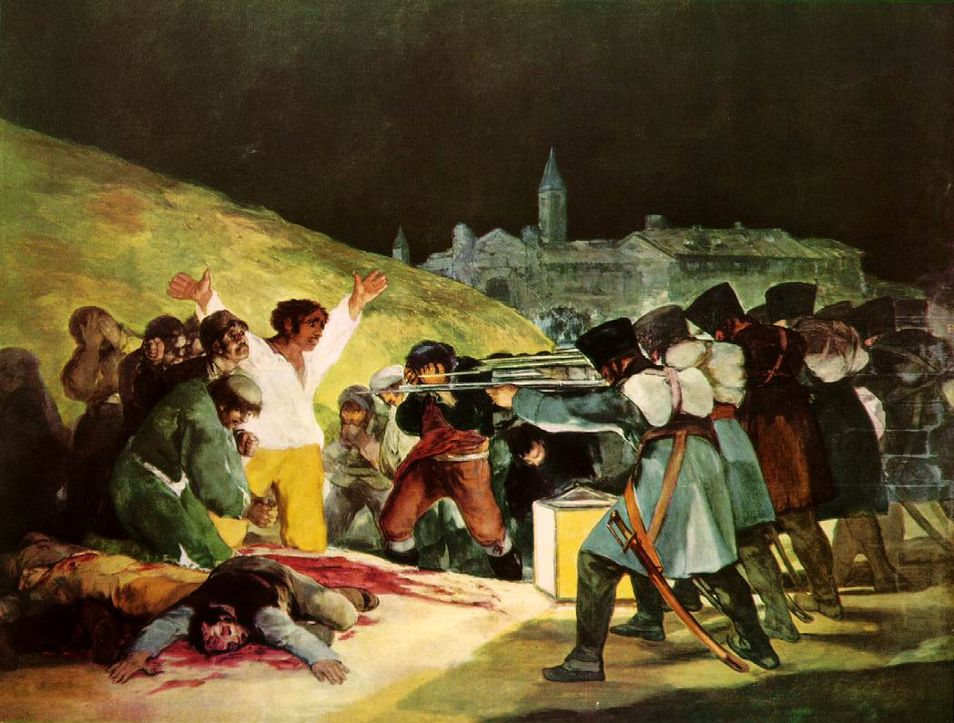

Document 9

Napoleon on Education of Women
Women do not need education, all they need is religion…
“...The husband must possess the absolute power and right to say to his wife: Madame, you shall not go out, you shall not go to the theater, you shall not visit such and such a person: for the children you bear, they shall be mine."
Docshare.com

Document 10

Napoleon’s Concordat of 1801
In consequence, after this mutual agreement recognition, as well for the benefit of religion as for the maintenance of internal tranquility, they have agreed as follows:
1. The catholic, apostolic and Roman religion shall be freely exercised in France: its worship shall be public, and in conformity with the police regulations which the government shall deem necessary for the public tranquility…
4. The First Consul of the Republic shall make appointments, within the three months which shall follow the publication of the bull of His Holiness, to the archbishoprics and bishoprics of the new circumscription. His Holiness shall confer the canonical institution, following the forms established in relation to France before the change of government.”
Western Heritage, p. 631

