IVAN THE TERRIBLE is one of the most ruthless tyrants in history.
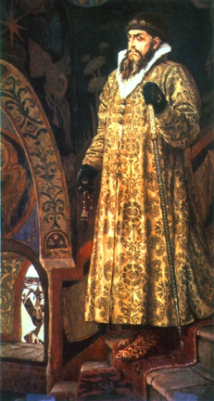 | He was Duke of Russia, tzar Ivan IV. He was known as Ivan the Terrible and earned his title. The name 'Ivan the Terrible' conjures up images of senseless cruelty and paranoia. Ivan appears to have been a man of huge contradictions - a man of God, who personally tortured his victims and beat his own son to death.  Born in 1530, Ivan was only three when he inherited the Russian throne following his father's death. At the age of seven, he lost his mother who was poisoned by nobles at court.  Ivan was crowned Russia's Tsar at the age of 17. Three weeks later he married, having chosen his bride in a national virgin contest. Virgins over the age of twelve were brought to the Kremlin to be paraded before him. He chose Anastasia Romanov, the daughter of a minor noble. His wife Anastasia helped to hold his cruelty in check, but in 1560 she died. He accused his nobles of poisoning her, and became even more mentally unstable.  Until recently, most scholars have dismissed Ivan's accusation of murder as evidence of his paranoia. But recent forensic tests on Anastasia's remains have revealed more than ten times the normal levels of mercury in her hair. It is likely, that Anastasia was indeed murdered, sending Ivan into a downward spiral of murder and cruelty.  Ivan had huge ambitions and launched a holy war against Russia's traditional enemy, the Tartars, showing no mercy to them. Ivan's conquest of Kazan, Astrakhan, and Siberia in the name of the church gave birth to a sixteenth century personality cult glorifying him as the Orthodox crusader.

The years 1547 through 1560 are usually considered the constructive period of Ivan's reign. He appointed an advisory council, founded a national assembly, enacted reforms in local governments and drew up a new law code that standardized the responsibilities and duties of the aristocracy. He was noted for his highly progressive administrative policies. | 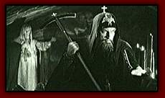
At the same time, he set up a secret police that has been described as the precursor to the KGB, the Oprichniki. They were ready to commit any crime in the Tsar's name. Ivan sentenced thousands to life–long exile in far-flung parts of the empire. Others were condemned to death; their families and servants often killed as well. Ivan would give detailed orders about the executions, using biblically inspired tortures to reconstruct the sufferings of hell. Several thousands people lost their lives from the hands of Ivan’s secret police.
He was a quick-tempered, irascible person, very hard to deal with. His elder son Ivan Ivanovich (1554-1581), the heir, a strong person and supporter of his father, did not always agree with him. During one of their hot disputes King Ivan struck his son with his heavy staff. The blow was to the temple and prince died. A painter, Ilia Repin, managed to show the tragedy of a father in his painting "Ivan and his son".
Mad with sorrow and guilt, Ivan the Terrible had a dramatic round–about, posthumously forgiving all those he'd executed and paying for prayers to be said for their souls. Before his death, Ivan was re-christened as the monk Jonah and buried as a monk in the hope of finding ultimate forgiveness.

