**Document Based Essay Question: Hinduism and Buddhism**

*Directions: Answer the questions using the documents below. Then use the documents to compare and contrast Hinduism and Buddhism.*

***Historical Context:***

*Throughout history, belief systems have influenced social, economic, and political developments in many regions. Although different, these belief systems often have similarities and, in some cases grow out of one another. Two such examples are Hinduism and Buddhism.*

**Document 1:****Achieving Moksha is the Goal of Life**

*To Hindus every person has an essential self or atman. Some view it as the same as Brahman and other as a form of Brahman. The ultimate goal of existence, Hindus believe, is achieving moksha, or union with Brahman. To do that, individuals must free themselves from selfish desires that separate them from Brahman. Most people cannot achieve moksha in one lifetime, but Hindus believe in reincarnation, or the rebirth of the soul in another bodily form. Reincarnation allows people to continue world toward moksha through several lifetimes.*

--Adapted from Prentice Hall World history, Ellis and Esler

**Document 1 Question: According to this excerpt, what is the purpose of reincarnation?**

**Document 2:** The following depicts the origins of the Hindu Caste system. The four major castes emerged from Purusha (the first human being). Purusha is identified with the creator god Brahma.



|  |
| --- |
| The Brahmins: The priestly class, born from the mouth of Brahma. |
| The Kshatriyas: Warriors and rulers, senators,  presidents, majors, born from the chest of Brahma |
| The Vaisyas: Farmers, merchants, lawyers, doctors. |
| The Sudras: Unskilled workers. Born from the feet of  Brahma. |
| Untouchables: Those who did jobs considered “unclean” (Butchers, street cleaners, etc) |

**Document 2 Question:** According to this diagram, who were the only people who could achieve moksha in their lifetime?

**Document 3:** The four truths are presented within the Buddha's first discourse, Setting in Motion the Wheel of the Dharma An English translation is as follows:

1. *"This is the noble truth of [suffering]: birth is [suffering], aging is [suffering], illness is [suffering], death is [suffering]; sorrow, lamentation, pain, grief and despair are [suffering]; union with what is displeasing is [suffering]; separation from what is pleasing is [suffering]; not to get what one wants is [suffering]; in brief, the five aggregates subject to clinging are [suffering]."*
2. *"This is the noble truth of the origin of [suffering]: it is this craving which leads to renewed existence, accompanied by delight and lust, seeking delight here and there, that is, craving for [physical] pleasures, craving for existence, craving for extermination."*
3. *"This is the noble truth of the cessation of [suffering]: it is the remainderless fading away and cessation of that same craving, the giving up and relinquishing of it, freedom from it, nonreliance on it."*
4. *"This is the noble truth of the way leading to the cessation of [suffering]: it is the Noble Eightfold Path; that is, right view, right intention, right speech, right action, right livelihood, right effort, right mindfulness and right concentration."*

--Adapted from Dhammacakkappavattana Sutta, translated by Thanissaro Bhikkhu

**Document 3 Question:** According to the Siddhartha Gautama (the Buddha), what is the origin of people's suffering?

**Document 4:** The Eightfold Path

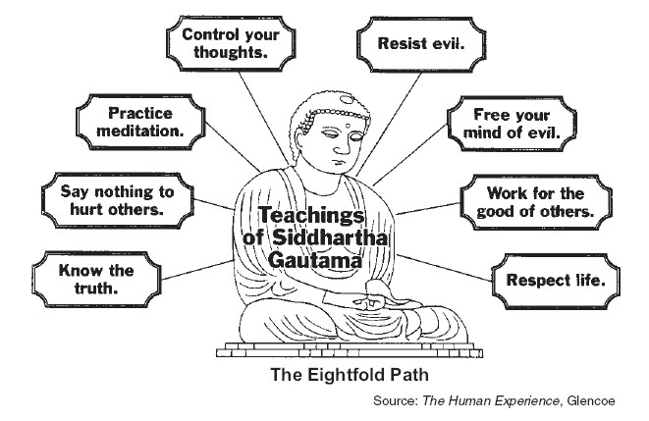

**Document 4 Question:** According to Siddhartha Gautama [the Buddha] what is an important part of the eightfold path.

***PART B: ESSAY***

*Directions: Write a well-organized essay that includes an introduction, several paragraphs, and a conclusion. Use evidence from* ***all four documents*** *in your essay. Support your response with relevant facts, examples, and details. Include additional outside information.*

***Task(s):*** *Using the information from the documents and your knowledge of global history, write an essay in which you:*

* *Describe the key beliefs and practices of both Hinduism and Buddhism.*
* *Discuss the differences, similarities and relationship between the two belief systems.*